1 Introduction
The document at hand is meant to specify the Software Requirements Specification (SRS) of the system called “Predicting Alzheimer’s Progression Using Multimodal Machine Learning on the ADNI Dataset”. This document will be the primary and official reference for all the participants in the project including the faculty supervisor, research team, software developers, and UX designers. The document will do this by explaining the system's scope, its functions, interfaces, quality attributes, and constraints. The primary audience for this document will include the clinicians (neurologists, geriatricians, and neuropsychologists), as well as the clinic staff, who will be using the dashboard for decision support, the researchers who will be reproducing and extending the models, the caregivers/patients who might be looking at the simplified risk views, and the course evaluators. The specifications are for research/educational software and not for a medical device, hence, the requirements are set to ensure methodological rigor, compliance with privacy regulations, and reproducibility rather than for clinical certification.

1.2 Scope of this document
- In-Scope: Data ingestion and harmonization will be performed along with subject-level splitting and provenance tracking. For each modality, feature extraction will take place followed by early/late fusion. Two-stage prediction (current & 12/24/36-month risk) will be done next along with probability calibration and generation of explainability artifacts (Grad-CAM/attention/feature contributions). Furthermore, the risk, longitudinal trends, and recommendations dashboards will be created. There will be a RBAC-secured user/patient management system in place along with REST APIs for data/predictions/model info/health, audit/logging, and exports for research reporting.
- Out-of-Scope: The use of clinical claims or bedside deployment, on-device data acquisition, regulatory submissions (e.g., FDA/CE), integration with EHR/HL7/FHIR, exploration of omics or modalities not accessible in ADNI (unless explicitly planned as future work).

1.3 Definitions & Acronyms
- ADNI: Alzheimer’s Disease Neuroimaging Initiative (standardized longitudinal cohort).
- CN / MCI / AD: Cognitively Normal, Mild Cognitive Impairment, Alzheimer’s Disease.
- T1-MRI: Structural MRI sequence used for volumetry and morphometry.
- MMSE / CDR-SB / ADAS-Cog: Common cognitive assessment scales used as tabular inputs.
- AUC / PR-AUC: Discrimination metrics for binary classification (ROC and Precision–Recall).
- ECE / Brier Score: Calibration metrics, quantify alignment between predicted probabilities and observed outcomes.
- Early vs. Late Fusion: Feature-level concatenation vs. ensembling/head-level aggregation across modalities.
- Modality Dropout / Presence Mask: Training and runtime strategies to remain robust when one or more modalities are missing.
- Grad-CAM / SHAP / Attention: Explanation methods for imaging, tabular, and text inputs, respectively.
- Subject-level Split: Ensures all visits of a subject reside in a single fold to prevent temporal/data leakage.

1.4 Business Context
The system has a wide range of target users among neurologists, geriatricians, neuropsychologists, researchers, and—through a simpler perspective—caregivers/patients who require regular, clear and near-term forecasts as input to their proactive care planning. Besides guaranteeing the privacy of the data used in each step, it also offers around-the-clock trust and readiness for decision-making concerning the fragmented tools. It is explicitly designated as research/educational software (not a medical device) and it also comes with UI disclaimers and usage limits that comply with ADNI policies. The success of the project is evaluated on the basis of (i) consistent discrimination and calibration on subject-level held-out splits, (ii) resistance to the absence of modalities, (iii) replicable experiments with the provision of documented preprocessing and model cards, and (iv) a user-friendly dashboard that highlights risk, uncertainty, and longitudinal context without causing any delays in clinical workflows. From the list of potential risks - undue interpretation of explanations, site/scanner bias, and over-confidence - the recommendation of clear guidance, harmonization choices, uncertainty display, and continuous calibration monitoring are the methods that minimize the risks.

2 Overall Description

2.1 Product Functions
- Data Curation: Import ADNI data, enforce subject-level splits, manage site/scanner/protocol metadata, optionally perform harmonization.
- Feature Extraction: Encoders for MRI (CNN/TL), clinical text (transformer or structured fields), and tabular (scaled cognitive/demographic features).
- Fusion & Inference: Early vs. late fusion pipelines, modality dropout for missing data.
- Two-Stage Heads: (a) Current AD at baseline, (b) probability of AD within 12–36 months.
- Calibration & Explainability: Temperature/Platt scaling, reliability diagrams, Grad-CAM/attention maps.
- Dashboard: Patient-level views (risk gauges and uncertainty bands), cohort comparisons, longitudinal trends, and actionable recommendations.
- User & Patient Management: Auth, roles, CRUD for patients, assessments, medications, activities, and appointments.
- APIs: REST endpoints for data, predictions, and model info/health.
- Audit & Logging: User actions, data access, and model inference logs.

2.2 Assumptions & Dependencies
- ADNI Data Use Agreement is in force, only permitted de-identified fields are stored/exported.
- Availability of pretrained encoders (medical CNNs/transformers) to bootstrap performance.
- Compute capacity supports 3D MRI preprocessing/inference, CPU path remains responsive for tabular/text.
- Stack continuity: React/Node/Mongo frontend/backend and Python (Flask/FastAPI) ML service with pinned versions.

2.3 User Characteristics
- Clinician (primary): Reviews patient risk & explanations, enters assessments, sets reminders.
- Caregiver/Patient (secondary): Views simplified risk insights & recommendations.
- Admin/Researcher: Manages users/roles, model versions, data subsets.

2.4 User Problem Statement
- The current tools being utilized in this specific medical field are scattered and frequently out of sync, exhibiting a deficiency in unified multimodal fusion and clear near-term predictions.
- Medical professionals demand a strongly dependable platform that integrates imaging, cognitive scores, and clinical data along with validation being made obvious.

2.5 User Objectives
- Reliable now/near-term predictions with leakage-free methodology and demonstrated calibration.
- Interpretable outputs (saliency/contributions) that are communicable to patients and actionable in care planning.
- Transparent metrics, ablations, and model cards, fast, coherent dashboard UX.

2.6 General Constraints
- Research-only software (not a medical device), disclaimers shown in UI and reports.
- Strict adherence to ADNI policy: de-identification, no re-identification or third-party redistribution, auditable access.
- Compute/runtime limits: cache embeddings, defer heavy MRI explanations to background jobs when needed.
- Reproducibility: subject-level CV, frozen split manifests, fixed seeds/configs, stored preprocessing hashes, encoder/calibration versions.

3 Functional Requirements

3.1 Data & Modeling
Functional Requirement (FR-01.1)
Priority & Ranking: System Depends On It (#1)
Function Name | Data Ingestion, Harmonization & Subject-Level Cohorting
Description | Allows the system to implement a reproducible pipeline to import ADNI multimodal data and produce a leakage-safe, subject-level research dataset with explicit train/validation/test splits.
Critically | All downstream feature extraction, fusion, and modeling depend on a correct, leakage-safe dataset.
Technical issues | Anticipated challenges include heterogeneous file formats and identifiers across ADNI phases, visit time alignment, site/scanner/protocol variability, incomplete modalities, and the risk of leakage if scalers/imputers are fit outside the training partition. Throughput and resumability are required for large I/O, checksums and retry logic are necessary to guarantee integrity.
Cost and schedule | 3–5 engineering days for ingestion, QC, harmonization, and split generation, and 2 days for validation, documentation, and provenance checks.
Risks | The primary risks are hidden data leakage (subject overlap or future information bleeding into training), site/scanner bias that shifts distribution, label noise when deriving progression windows, and silent record loss that distorts cohort characteristics.
Dependencies with other requirements | This requirement enables FR-01.2 (Feature Extraction), FR-01.3 (Fusion & Missing-Data Handling), FR-01.4 (Two-Stage Prediction), FR-01.5 (Calibration & Interpretability), and FR-05.2 (Model Versioning/registry).
Pre-Condition | Valid ADNI credentials & local data dictionary.
Post-Condition | Cleaned, aligned per-subject dataset with split manifests.
Inputs | Raw ADNI files & CSVs, and configuration for inclusion/exclusion.
Outputs | Standardized parquet/NPZ/JSON, split files and provenance log.

Functional Requirement (FR-01.2)
Priority & Ranking: System Depends On It (#1)
Function Name | Multimodal Feature Encoders
Description | Allows the system to convert each modality into a fixed-length embedding using stable, reproducible pipelines. MRI volumes are preprocessed and encoded with a 3D CNN or transfer-learning encoder, clinical text or structured fields are normalized and embedded with a transformer or MLP, tabular cognitive and demographic variables are imputed and scaled before MLP encoding. All embeddings carry provenance (subject, visit, preprocessing and encoder versions) to guarantee traceability.
Critically | Downstream fusion and prediction depend on embeddings.
Technical issues | MRI memory/VRAM footprint, heterogeneous field-of-view, text length truncation, leakage from future visits, imputation bias, ensuring subject‑level split integrity during scaler/fit steps.
Cost and schedule | 3–5 engineering days to stand up pipelines if using existing libs, and 2–3 days for QA and caching.
Risks | Collinearity across tabular features, site/protocol bias in MRI, missing modalities at inference, encoder version drift.
Dependencies with other requirements | FR‑01.1 (ingestion), FR‑01.3 (fusion), FR‑01.5 (calibration needs stable features), FR‑05.2 (versioning of encoders).
Pre-Condition | Cleaned inputs available, split manifests frozen, encoder configs chosen.
Post-Condition | Modality‑specific tensors cached to disk/DB, with metadata and checksums.
Inputs | T1‑MRI volumes, clinical text/structured CSVs, and cognitive/demographic tables, preprocessing configs.
Outputs | MRI embedding, text embedding (or structured), embedded tables and metadata JSON.

Functional Requirement (FR-01.3)
Priority & Ranking: System Depends On It (#1)
Function Name | Multimodal Fusion Layer
Description | Allows the system to combine modality embeddings using either early fusion (feature concatenation) or late fusion (ensembling of per‑modality heads). The fusion layer must operate when one or more modalities are absent by learning presence‑aware gating and training with modality dropout. When site or scanner shifts are present, optional domain alignment reduces bias while preserving predictive utility.
Critically | Enables inference when some modalities are missing and improves performance over unimodal baselines.
Technical issues | Training instability with adversarial loss, imbalance in modality quality, ensuring gradients flow when modality is absent, calibration drift across fusion types.
Cost and schedule | 3–4 days to implement and benchmark early vs late fusion, and 2 days for missing‑data ablations.
Risks | Overfitting to sites, degraded performance if gating mislearned, silent failures when a modality path breaks.
Dependencies with other requirements | FR‑01.2 (embeddings), FR‑01.5 (post‑fusion calibration), FR‑05.2 (model variants registry).
Pre-Condition | Valid embeddings for at least one modality, presence mask available.
Post-Condition | Unified fused representation or ensemble probability with contribution report.
Inputs | We optionally compute MRI, text, and tabular feature vectors, record which modalities are present using a mask, and apply a fusion configuration to combine them.
Outputs | Combined feature vector (early) or combined prediction probabilities (late), contribution weights.

Functional Requirement (FR-01.4)
Priority & Ranking: Extremely High (#2)
Function Name | Prognostic Heads (Now & 12–36m)
Description | Allows the system to produce a calibrated probability for current AD status at baseline and separate horizon‑specific probabilities for progression at 12, 24, and 36 months. Labels are constructed to avoid temporal leakage and account for censoring or class imbalance. The module may optionally expose uncertainty estimates to communicate confidence.
Critically | Central research output communicated to users.
Technical issues | Label curation for progression, censoring, class imbalance, temporal leakage, aligning visit times.
Cost and schedule | 4–6 days to implement/train/evaluate, and 2 days for uncertainty estimation.
Risks | Over‑confident predictions, confusing multi‑horizon outputs, and degradation under missing MRI.
Dependencies with other requirements | Over‑confident predictions, confusing multi‑horizon outputs, and degradation under missing MRI.
Pre-Condition | Trained fusion encoder, and labeled datasets with subject‑level splits.
Post-Condition | Saved model weights, eval metrics, and serving endpoints.
Inputs | Combined feature vector or per‑modality probabilities, label manifests, and training configs.
Outputs | Calibrated probability of Alzheimer’s now, probability of it in 1 to 3 years and uncertainty.

Functional Requirement (FR-01.5)
Priority & Ranking: Extremely High (#2)
Function Name | Calibrator & XAI Artifacts
Description | Allows the system to calibrate predicted probabilities on a held‑out split and report reliability with ECE/Brier and reliability diagrams. Generate patient‑level explanations appropriate to each modality (e.g., Grad‑CAM for MRI, SHAP for tabular, attention/IG for text). Explanations are packaged with model/version metadata for consistent rendering in the UI.
Critically | Mandatory for trustworthy probabilities and educational value.
Technical issues | Calibration shift across sites, saliency robustness, SHAP cost on large tabular sets, linking artifacts to visits securely.
Cost and schedule | 2–3 days for calibration and plots, 3–4 days for XAI artifacts and UI hooks.
Risks | Misinterpretation of saliency, leakage if explanations expose sensitive text, compute overhead.
Dependencies with other requirements | FR‑01.4 (raw probabilities), FR‑03.2 (explainability views), and FR‑05.2 (store calibrator version).
Pre-Condition | Trained model, reserved validation split.
Post-Condition | Calibrated scorer, reliability/interpretability artifacts persisted.
Inputs | Model logits/probabilities, validation labels, MRI volumes, tabular/text inputs.
Outputs | Calibrated probabilities, ECE/Brier, Grad‑CAMs, SHAP/attention visuals, and per‑patient explanation bundle.

3.2 Web Application & APIs
Functional Requirement (FR-02.1)
Priority & Ranking: Extremely High (#2)
Function Name | RBAC Auth Gateway
Description | Allows the system to provide secure login, token issuance, and role‑based access control for all protected resources. Sessions rely on short‑lived access tokens with refresh support and middleware guards on server routes. The system logs claims and key events to support auditing and incident response.
Critically | Protects patient data and model endpoints.
Technical issues | Token revocation/rotation, secure storage of refresh tokens, clock skew, CORS and CSRF.
Cost and schedule | 2–3 days to implement, 1 day for penetration checks.
Risks | Credential stuffing, token leakage, misconfigured CORS exposing APIs.
Dependencies with other requirements | FR‑05.1 (audit actions), and NFR‑Security.
Pre-Condition | User exists or Admin can invite, HTTPS configured.
Post-Condition | Authenticated session with role claims, denied access otherwise.
Inputs | Email/password (or SSO, if configured), and JWT.
Outputs | Access/refresh tokens, and standardized auth errors.

Functional Requirement (FR-02.2)
Priority & Ranking: Extremely High (#2)
Function Name | Clinical CRUD Services
Description | Allows the system to persist and manage core clinical entities (Patients, Assessments, Medications, Activities, Appointments) with validation and indexing. Provide search, pagination, and filters, enforcing ownership and permissions at the API layer. Emit structured events for audit trails and downstream analytics.
Critically | Core clinical data backbone for predictions and dashboards.
Technical issues | Referential integrity, concurrent edits, time‑zone handling, validation of medical units.
Cost and schedule | 4–6 days including UI forms and server validators.
Risks | Data inconsistency, accidental PII exposure, orphaned records if cascading deletes not handled.
Dependencies with other requirements | FR‑02.1 (auth), FR‑03.1 (dashboard consumes), and FR‑05.1 (audit).
Pre-Condition | Authenticated user with proper role.
Post-Condition | Persisted entities, index updates, and events logged.
Inputs | Form payloads (patient demographics, assessment scores, meds, activities, and appointments).
Outputs | Saved documents, list/search results, and validation errors.

Functional Requirement (FR-02.3)
Priority & Ranking: Extremely High (#2)
Function Name | Inference Proxy & Health
Description | Allows the system to expose normalized endpoints that validate input, forward inference requests to the Python ML service, and standardize responses (probabilities, uncertainty, explanations). Implement timeouts, retries, and health checks to keep the UI responsive and inform users about model readiness. Include model/version information in responses for traceability.
Critically | Connects UI/DB with ML service reliably.
Technical issues | Cross‑service timeouts, serialization of large artifacts (Grad‑CAM images), version skew.
Cost and schedule | 2–3 days including error handling and tests.
Risks | Silent degradation if fallback paths not explicit, DOS via heavy inference requests.
Dependencies with other requirements | FR‑01.4/01.5 (model outputs), and FR‑05.3 (health/alerts).
Pre-Condition | ML API reachable, service discovery configured.
Post-Condition | Standardized inference responses for UI/storage.
Inputs | Patient/visit payload, requested horizons, and flags for explanations.
Outputs | Probability of Alzheimer’s at a specific time, uncertainty, explanation bundle, and model metadata.

3.3 Dashboard & Visualization
Functional Requirement (FR-03.1)
Priority & Ranking: High (#3)
Function Name | Risk & Longitudinal UI
Description | Allows the system to present a cohesive patient view with risk gauges, uncertainty bands, horizon selectors, and longitudinal charts of assessments, medications, activities, and appointments. Surface quick actions and clear status indicators to streamline clinical workflows. All visuals reflect the latest data and selected model version.
Critically | Primary decision surface for clinicians.
Technical issues | Chart performance, syncing time axes, accessibility, caching.
Cost and schedule | 4–6 days for views and 2 days for polishing.
Risks | Misinterpretation of risk visuals, stale caches, slow charts on large histories.
Dependencies with other requirements | FR‑02.2 (data), FR‑02.3 (predictions), and FR‑01.5 (artifacts).
Pre-Condition | Authenticated clinician, patient selected with data.
Post-Condition | Up‑to‑date rendered dashboard panels.
Inputs | Patient entities, prediction results, and calibration/XAI artifacts.
Outputs | Interactive UI components, and exportable charts.

Functional Requirement (FR-03.2)
Priority & Ranking: High (#3)
Function Name | XAI UI Panels
Description | Allows the system to render modality‑specific explanation artifacts and concise narratives that help users interpret each prediction. Visual elements follow consistent scales and legends and are linked to the patient visit and model version. Secure download options are provided for research reporting when authorized.
Critically | Increases transparency and educational value.
Technical issues | Serving large images, PHI safety in text snippets, consistent color scales.
Cost and schedule | 3–5 days including accessibility and downloads.
Risks | Over‑trust due to visual artifacts, data leakage via text tokens.
Dependencies with other requirements | FR‑01.5 (artifacts), FR‑02.3 (delivery), and NFR‑Privacy.
Pre-Condition | Prediction with explanations available.
Post-Condition | XAI panels rendered, artifacts linked and/or downloaded.
Inputs | Grad‑CAM images, SHAP rankings, attention snippets, model metadata.
Outputs | Explanations UI, and downloadable assets.

3.4 Audit & Operations
Functional Requirement (FR-04.1)
Priority & Ranking: High (#3)
Function Name | Audit Logger
Description | Allows the system to record security‑relevant and clinical events with timestamps, actor identifiers, patient context, and outcomes. Logs are immutable, queryable, and exportable with defined retention periods. Correlation identifiers enable tracing requests across services.
Critically | Forensic traceability and compliance.
Technical issues | Log volume, PII minimization, secure storage, correlation IDs.
Cost and schedule | 2–3 days to implement, and 1 day for exports/indexes.
Risks | Storage bloat, missing events, insecure log access.
Dependencies with other requirements | FR‑02.1 (user identity), and NFR‑Security.
Pre-Condition | Authenticated routes, log sink configured.
Post-Condition | Durable, queryable audit records.
Inputs | Event objects from middleware/services.
Outputs | Log streams, exports, and alerts (via FR‑05.3).

Functional Requirement (FR-04.2)
Priority & Ranking: High (#3)
Function Name | Model Registry
Description | Allows the system to maintain a registry of model artifacts, training data hashes, metrics, and calibration parameters. Allow controlled promotion and rollback of serving versions with auditable change logs. Expose lightweight APIs so the UI and backend can resolve the active model consistently.
Critically | Reproducibility and safe iteration.
Technical issues | Artifact storage, schema evolution, hash reproducibility.
Cost and schedule | 2–3 days to set up, and 1 day for UI hooks.
Risks | Serving wrong version, orphaned artifacts, metric mismatch.
Dependencies with other requirements | FR‑01.2/01.4/01.5, and FR‑02.3 (serving needs active model).
Pre-Condition | Trained models exist, storage configured.
Post-Condition | Versioned entries, one marked active.
Inputs | Model files, metrics JSON, and notes.
Outputs | Registry records, and active model pointer.

Functional Requirement (FR-04.3)
Priority & Ranking: High (#3)
Function Name | Resilience & Health Monitor
Description | Allows the system to standardize error envelopes, implement timeouts and retries, and expose health/readiness probes for all services. Trigger actionable alerts on repeated failures or unhealthy states while minimizing noise. Provide user‑facing status messages that explain degraded behavior without exposing internals.
Critically | Operational stability.
Technical issues | False positives, noisy alerts, cascading timeouts.
Cost and schedule | 2–3 days including dashboards for health.
Risks | Alert fatigue, hidden partial failures.
Dependencies with other requirements | FR‑02.3 (proxy), and NFR‑Reliability.
Pre-Condition | Deployed services with metrics endpoints.
Post-Condition | Measurable health, actionable alerts, graceful errors.
Inputs | Error events, health pings, thresholds.
Outputs | Alert notifications, error responses, and status pages.

Functional Requirement (FR-04.4)
Priority & Ranking: Moderate (#4)
Function Name | Research Exporter
Description | Allows the system to generate anonymized export bundles that include prediction tables, logs, and selected visualizations for approved cohorts and time windows. Ensure de‑identification rules are enforced consistently before packaging. Provide progress feedback and an auditable record of exports.
Critically | Convenience for research dissemination.
Technical issues | Large export bundles, chart rendering server‑side, privacy checks.
Cost and schedule | 2–3 days.
Risks | Accidental re‑identification, incomplete exports.
Dependencies with other requirements | FR‑03.1/03.2 (visuals), FR‑05.1 (logs), and NFR‑Privacy.
Pre-Condition | Data present and user authorized.
Post-Condition | Downloadable archive generated.
Inputs | Query params, selection of artifacts.
Outputs | ZIP with CSV/JSON and images.

3.5 Compliance & Ethics
Functional Requirement (FR-05.1)
Priority & Ranking: Moderate (#4)
Function Name | Consent & Policy Guardrails
Description | Allows the system to enforce ADNI data‑use rules by tagging sensitive fields, validating requests against consent flags, and blocking or redacting disallowed operations. Administrators can configure additional research‑only restrictions for exports and displays. Every enforcement action is logged for audit.
Critically | Ethical and legal compliance.
Technical issues | Mapping ADNI policy to fields, preventing side‑channel re‑identification, policy drift.
Cost and schedule | 2 days.
Risks | Non‑compliance, accidental PHI exposure.
Dependencies with other requirements | FR‑02.2 (data fields), FR‑05.4 (export), and NFR‑Privacy.
Pre-Condition | Policy documented, fields tagged with sensitivity.
Post-Condition | Requests violating policy are blocked or redacted.
Inputs | User role, requested fields/actions.
Outputs | Allowed action or policy error, redacted payloads.

Functional Requirement (FR-05.2)
Priority & Ranking: Low (#5)
Function Name | Risk Education Module
Description | Allows the system to provide inline explanations of probabilities, calibration, uncertainty, and thresholding with concise, plain‑language help. Content appears contextually in the dashboard and links to a glossary and a short “how to read this” guide. Materials are versioned alongside the active model.
Critically | Reduces misuse and improves decisions.
Technical issues | Localization/readability, keeping content synced with model updates
Cost and schedule | 1–2 days.
Risks | Over‑simplification or misunderstanding, outdated content after model change.
Dependencies with other requirements | FR‑03.1/03.2 (UI), and FR‑01.5 (calibration terms).
Pre-Condition | Predictions visible, user in dashboard.
Post-Condition | Help panels/tooltips rendered.
Inputs | Current model metadata, and glossary content.
Outputs | Contextual help and disclaimers.

4 Non-functional Requirements

4.1 Security (NF-R1) | Priority: High
The entire clinical research data and model artifacts need to be comprehensively protected by the system from the storage through to the execution. All APIs are secured by the TLS protocol, authentication is accomplished through the use of short-lived access tokens that can be refreshed, and authorization is done by applying the least-privilege role scopes that consist of Admin, Clinician, Researcher, Caregiver/Patient at the route and query levels. Secrets are kept in separate stores for different environments, passwords are protected through the use of salts and hashing, all inputs are checked for validity on the server side in order to avoid risks of injection and deserialization, and there is private object storage that uses signed URLs for granting access to the MRI saliency maps and reports. Logs do not contain PHI and are divided according to tenant/project. The threat model takes into consideration attacks such as credential stuffing, token leakage, CSRF/CORS misconfiguration, model endpoint abuse, and artifact tampering, the mitigations include rate limiting, IP throttling on auth routes, strict CORS, token rotation, audit trails, and checksums for integrity on model and embedding files. Security verification activities include static analysis, dependency scanning, and periodic penetration testing of the authentication gateway and machine learning endpoints.

4.2 Reliability & Recovery (NF-R2) | Priority: High
In case of issues with the ML service or a downstream datastore, clinical workflows must not be interrupted. The backend applies timeouts, retries with exponential backoff, and circuit breakers about the Python ML API, when the UI is degraded, it shows a clear state and allows to load previously cached results while queuing non-critical jobs. Health and readiness probes input a simple operations dashboard, MongoDB and the model registry backups are done daily with point-in-time recovery, artifact stores are versioned and non-writable. The service level expectations are 99.5% monthly availability for the web/API tier and a successful recovery of the primary database within four hours from a severity-1 incident. Fault injection tests verify that the system still allows reads, blocks unsafe writes, and automatically recovers from typical failure types such as ML timeouts, network partitions, and storage hiccups.

4.3 Maintainability (NF-R3) | Priority: Medium/High
The architecture of the codebase is separated into packages for frontend, backend and ML services with defined interfaces, semantic versioning and continuous integration for unit and integration tests that are automated. The common agreements (schemas used for prediction, calibration metadata) are created just once and then shared among the services to keep drift under control. Linting, formatting and typed models contribute to lowering the complexity that is not intended, the infrastructure is coded to prevent configuration discrepancies between environments. Operational activities like model promotion, rollback, and calibrator updates are written down and a change log tracks the evolution of the schema and endpoints. So the target is that a new employee can carry out a minor implementation or bug fix in one day, also, a routine update does not necessitate a coordinated downtime that is prearranged. Maintenance is measured in terms of test coverage, build health, and mean time to restore after regressions.

4.4 Portability (NF-R4) | Priority: Medium
Deployment must be done in a way that it can be used in both on-premises and cloud environments without any code alterations. Services are deployed in containers and are configured through environment variables, the use of external databases, caches, and storage is done through drivers so that MongoDB, Redis, and S3-compatible storage can be easily replaced with their managed versions when they become available. In the machine learning service, GPU usage is determined by the current availability: if there is no CUDA, the system will use CPU for tabular/text paths and will wait for an MRI-heavy explainability job to be processed in order not to fail. Build artifacts are created for multiple architectures if it is feasible, and the application can work with standard ingress and logging practices for local or managed stack connectivity. Portability is confirmed by launching the entire system with docker-compose on a local machine and then using the same images on a cloud runner with only changing the environment variables.

4.5 Extensibility (NF-R5) | Priority: Medium
It should be possible to incorporate new modalities, features, and model variants into the system without carrying out disruptive refactors. Encoders are designed to adhere to a standard interface that produces both embeddings and provenance, which in turn enables the fusion layer to receive more inputs like PET or CSF biomarkers if they are present. The model registry retains any kind of metadata that is needed so that different architectures can be run at the same time and A/B tested. The dashboard on the UI side is made up of panels that are connected to a unified prediction schema, thus allowing the addition of new horizons, uncertainty measures, or explanation types without having to rewrite existing views. The system shows its extensibility through the incorporation of one new feature family or encoder within a single sprint, followed by complete propagation to inference, calibration, storage, and visualization.

4.6 Accessibility & Reusability (NF-R6) | Priority: Low
The authorized contributors should have accessibility to the system's code along with the data assets and make them available for research replication. Every dataset has its respective split manifests, preprocessing hashes, and data dictionaries in order to enable the exact replication of experiments; models consist of training configs, metric cards, and calibration parameters. The reusability of UI components (risk gauges, longitudinal charts, explanation panels) is an advantage as they are made available internally in libraries and thus, across the pages they are reused. The documentation addresses environment setup, experiment reproduction, and data-use compliance, which allows new researchers to contribute responsibly as it lowers the barrier for them. Accessibility is evaluated based on the time taken to reproduce a benchmark experiment starting from a clean checkout and the ratio of components that are shared across features instead of being rewritten.

4.7 Resource Utilization (NF-R7) | Priority: High
The whole process of inference and explanation should be so efficient that the feedback given to clinicians would be quick and the compute costs would still be predictable. The completion time for tabular/text-only requests should be approximately three seconds on CPU, for MRI-based requests, the expectation is to stay within fifteen seconds when Grad-CAM is asked for, with asynchronous rendering in case it is necessary. Caching of embeddings, deduplication of the repeated requests within a very short period, and streaming of large artifacts from object storage instead of through the API are among the measures taken to reduce resource usage. The batch prediction endpoints are made in such a way that they can support cohort analyses without the risk of overloading interactive services, and the background workers are scaled apart from the web tier to avoid noisy-neighbor effects. Tracking of resource usage is done per request type and per model version so that the hotspots can be either tuned or offloaded, also, the budgets are enforced through queue limits and concurrency caps.

4.8 UI Accessibility & Serviceability (NF-R8) | Priority: Medium/High
The interface has to be easy to use and to maintain in actual clinical environments. The pages have been designed following the WCAG 2.1 AA principles and they provide keyboard navigation, visibility of focus, and sufficient contrast between the text and background along with proper labeling of charts and icons, risk and uncertainty are communicated in straightforward terms with illustrations to avoid misunderstanding. The UI is still usable on small screens and with low-bandwidth connections, and it offers progressive loading and visible empty states. Features for serviceability include a machine learning availability status indicator in the app, error IDs that can be copied and correspond to the server logs, and a channel for clinicians to send feedback about patient-specific issues and predictions. Accessibility is assured through the combination of automated checks, and user testing while serviceability is assessed by the difficulty of linking a user-reported problem to a log trace and resolution steps.

4.9 User Activity Logging (NF-R9) | Priority: High
All interactions that are significant from a security or clinical perspective are logged in such a way as to create an auditable trail that can be defended, without revealing any PHI. The system logs all the mentioned events, like authentication, CRUD operations, data exports, and also timestamps, and identifies the actors, the patient context, the route names, request fingerprints, and outcomes along with their sensitive payloads, which are summarized instead of being stored. The correlation IDs trace a request throughout its journey so that the investigators can map the flows across different services, and the retention policies make sure that the logs stay accessible for the purpose of review and at the same time the data-use agreements are observed. The access to the logs is limited to specific roles and not detectable by tampering, operational analytics also signal potential misuse or faults in the system by receiving the rates and anomalies. The completeness of the audit is tested from time to time using simulated user journeys and by checking the UI actions against the events recorded.

5 System Models

5.1 Use Case Diagram (actors & goals)
- Actors: Admin, Clinician, Caregiver/Patient, Researcher.
- Core Use Cases: Authentication, Manage Patients, Assessments, Medications, Activities, and Appointments, Submit Predictions, View Risk & Explanations, Download Reports, and Manage Models.
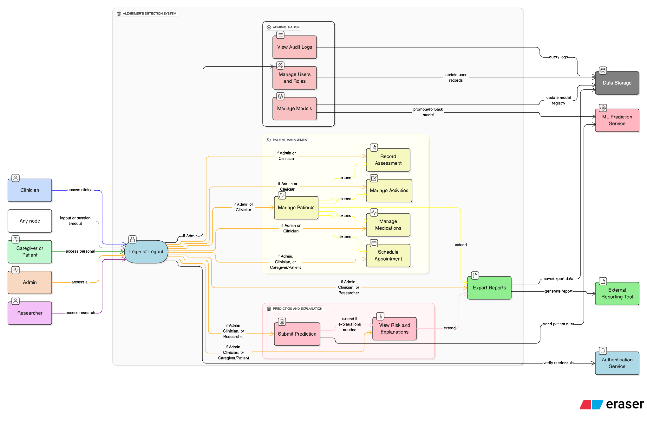

5.2 Activity Diagram

1) Schedule Appointment (With Accept/Reject and Follow-up)
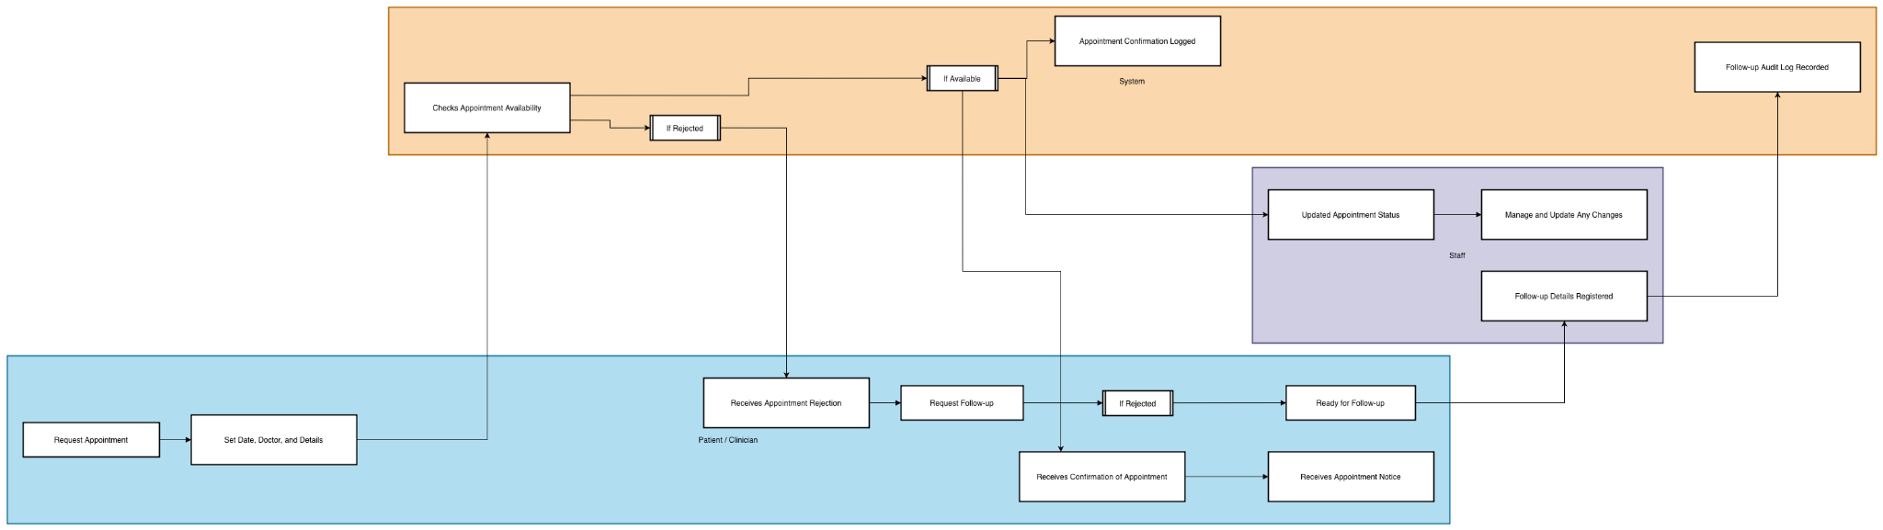

2) End-to-End AI Prediction
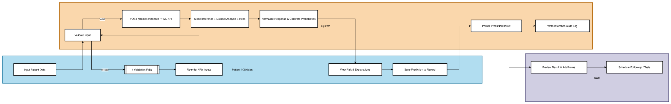

3) Record Assessment (With Authentication and Patient Existence)
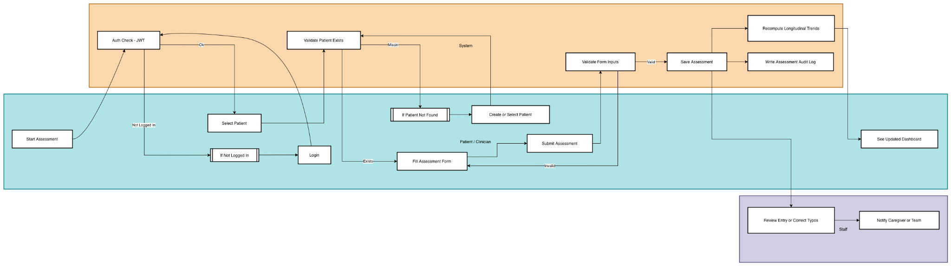

4) Medication Management (Add / Edit / Delete / Mark Taken)
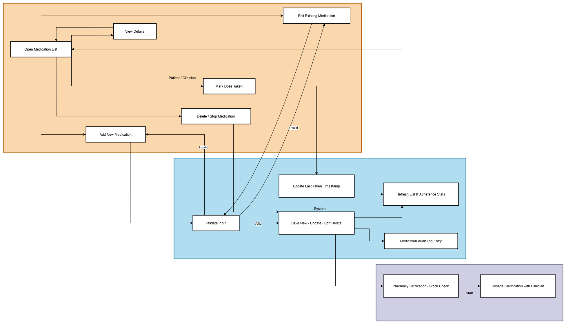

5) Contact Information Update (Validate and Audit)
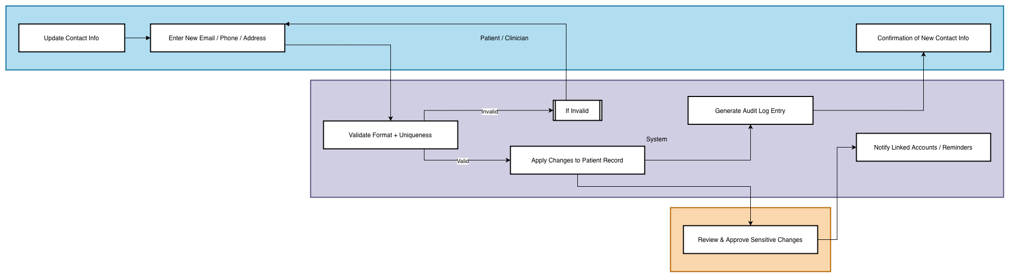

5.3 Class Diagram
- Entities: User, Patient, Assessment, Medication, Activity, Appointment and PredictionResult.
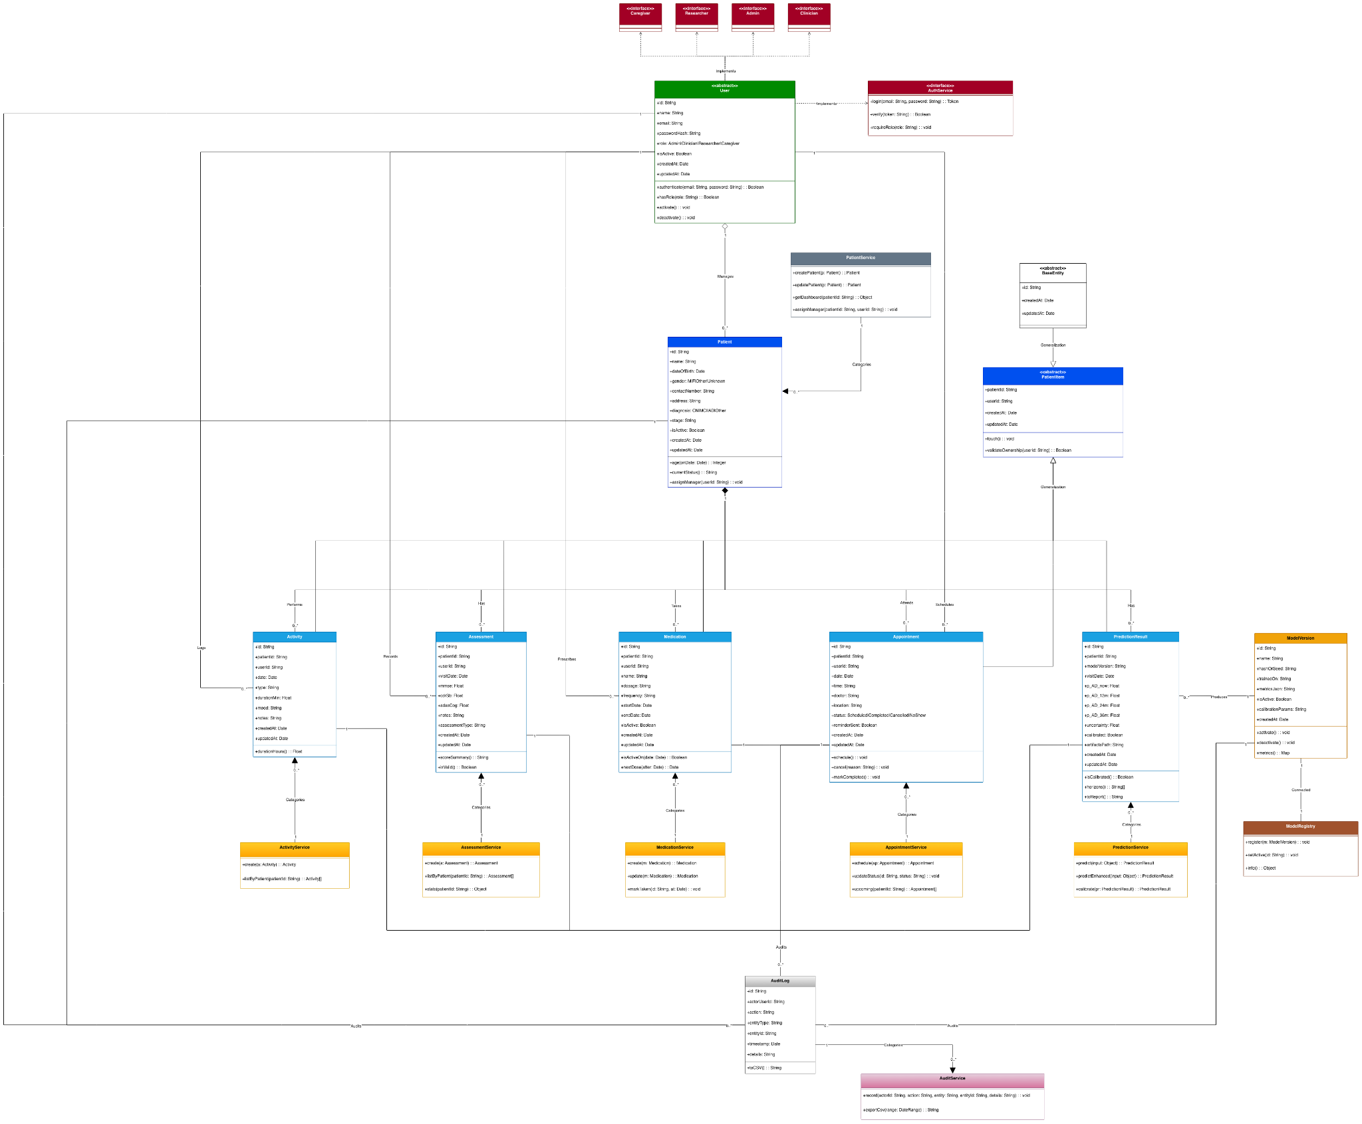

5.4 ER Diagram (data persistence)
- Collections/Tables reflecting the domain entities with one-to-many relationships from User and Patient.
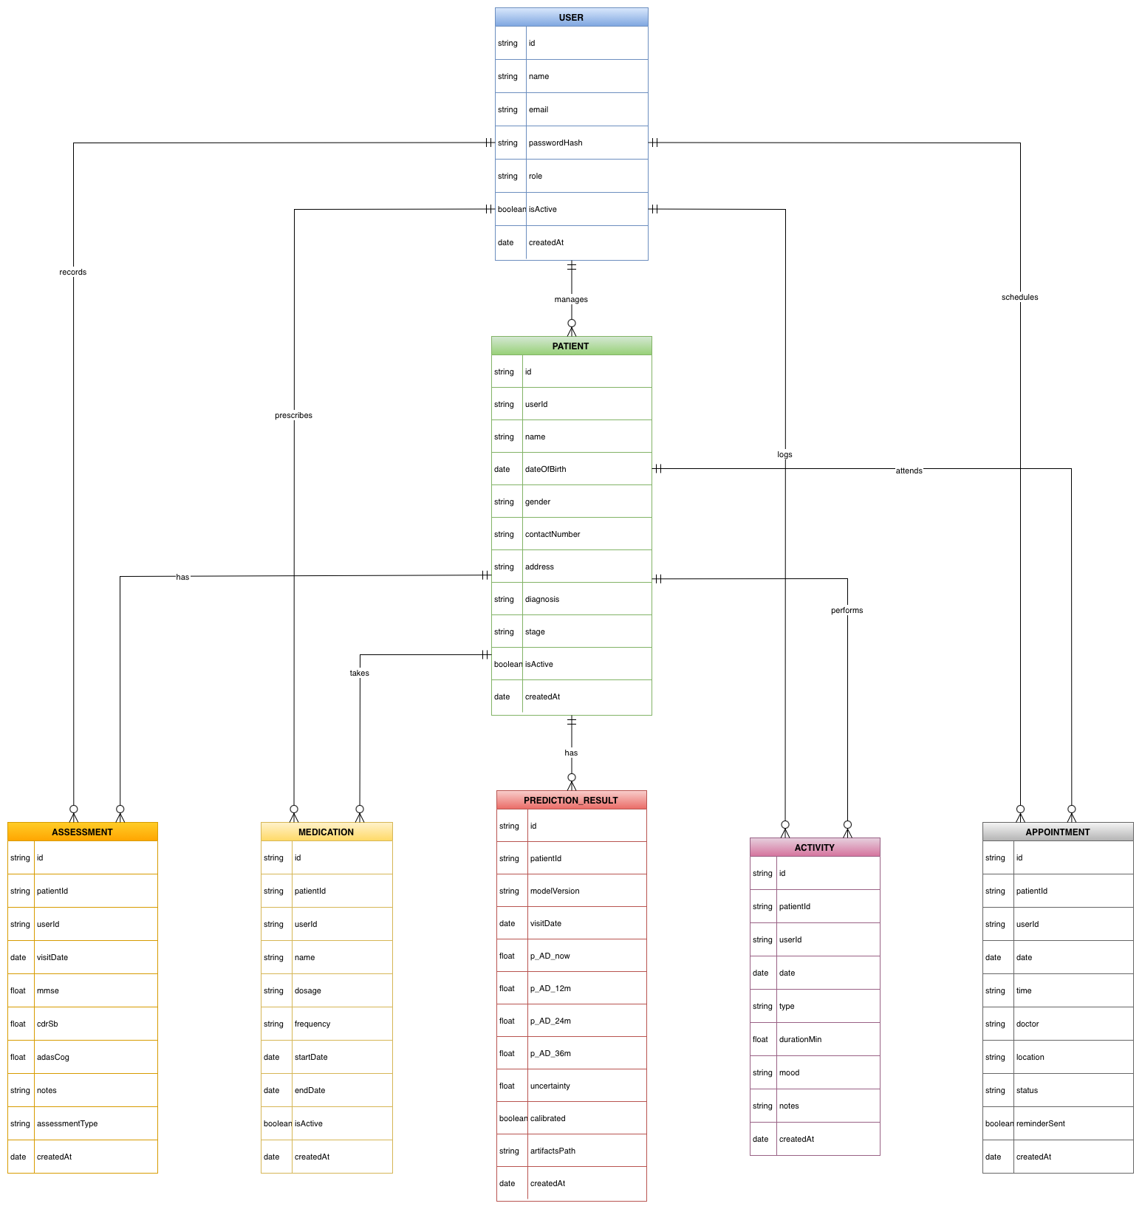

6 Constraints

6.1 Standards Compliance
The project will follow the ADNI Data Use Agreement and general research ethics: only de-identified fields approved by ADNI will be kept, subject IDs will be pseudonymous, no re-identification attempts will be made, no raw data will be distributed to third parties, and access to data will be allowed only to specific researchers with a valid reason. Every dataset and export comes with a provenance tag (source, date, version) and consent flags, so UI/API layers can prevent or conceal sensitive fields at the time of access. Secure coding is done according to OWASP standards—input validation, output encoding, authentication/authorization at the least privilege level, secrets isolation, and dependency/container scanning—and changes are reviewed through pull requests that include automated checks. Reporting for machine learning must include the following: production results with subject-level splits which help avoid leakage, hold-out calibration is compulsory and reported with ECE/Brier and reliability diagrams, and ablation studies must indicate fusion variants of missing-modality behavior. Also, every serving model has to publish a lightweight "model card" that contains training data hash, metrics per subgroup where feasible, known limitations, and calibration method. A data retention policy is in place that outlines the duration of keeping of intermediate artifacts (e.g. embeddings, Grad-CAM images) and the methods for their disposal. Audit trails log the access to subjects, the name of the person who accessed, and the reason why.

6.2 Hardware Limitations
The processing of 3D MRI and its inference are very demanding in terms of computing power and, in many cases, standard demo hardware's VRAM/CPU limitations get easily exceeded. To ensure that the system is still usable on cheaper GPUs (≤12 GB) or CPU-only nodes, the pipeline limits input resolution through resampling/cropping, adopts mixed precision in the parts of the pipeline that support it, and moves non-interactive tasks (like Grad-CAM generation) to background workers with queue-based throttling which consequently limits their resource usage. For 3D models, batch sizes are set to a maximum of 1-2, and embedding caching is applied so that repeat requests do not involve re-encoding volumes, and this is how the inference time target is met. Raw volumes (in case they are staged locally), preprocessed volumes, embeddings, and explanation artifacts all need storage, practical sizing should take into account tens of GBs for imaging plus several GBs for cached tensors in a small cohort and with automatic TTLs on caches, and should assume this for the entire duration. Network bandwidth limitations hinder the download of explanation artifacts and the export of cohorts, thus, the UI streams large images, provides “click-to-load” for heavy panels, and compresses/tiles MRI overlays to minimize long blocking times. Even when there is no GPU, the system is still able to provide tabular/text predictions synchronously and to schedule the MRI-derived artifacts asynchronously.

6.3 Development and Deployment Constraints
The current project's stack still determines in which directions new features will go, thus, React (for the front end), Node/Express (for the back end), MongoDB (for the data store), and Flask/Python (for the ML API) are besides that. The versions of all dependencies are fixed (via package.json/requirements.txt and container images) to avoid discrepancies, Python models have to be compatible with the chosen interpreter (e.g. 3.10.x) and, if necessary, the CUDA/cuDNN versions that the target host has available. Disallowing changes in REST schema compatibility means that changes will be cumulative and versioned (/v1 versus /v2) to not disrupt the UI already in place, Mongo schema evolution is done in accordance with a migration script pattern while having read-compat layers until all records are updated. The CI/CD constraints necessitate all services to be built and to pass unit/integration tests in isolated containers, environment configuration is done only through variables and secret managers—no credentials embedded in code. Since the website is already in place, endpoint names and response shapes utilized by the production screens should remain the same, on the contrary, new endpoints or response fields should be introduced and old ones marked as deprecated with a sunset date in the change log.

6.4 Scalability and Maintainability
The web/API and ML tiers are set up just like stateless services behind a load balancer, so they can be scaled horizontally. Worker pools that are attached to a queue with limits on the number of concurrent users do interactive traffic so that long-running calculations (MRI explanations, cohort batch runs) are executed in a responsive manner. Patient-centric indexing (e.g., patientId, visitDate, createdAt), query projection of only required fields, and optional caching of hot queries are the means through which read performance is sustained, the write amplification is reduced to a minimum because of the predictions stored in append-only logs and the use of immutable model artifacts. It is not optional to have observability: centralized logs with correlation IDs, request metrics (latency, error rates) broken down by endpoint and model version, and health/readiness probes are used to inform autoscaling and alerting. The use of modular services, shared typed contracts, and a model registry that clearly separates training artifacts from serving configuration are all maintainability supports that enable quick promotion/rollback without redeploying the UI. All routine operations—backups, restores, schema migrations, and model promotions—are scripted and documented, disaster-recovery rehearsals confirm that full database and registry restores are achievable within the defined RTO/RPO windows while maintaining audit integrity.

7 Interface Requirements

7.1 User Interfaces
- Web dashboard with risk gauges, longitudinal plots, explanation panes, and CRUD forms for clinical records, responsive layouts, tooltips.

7.2 Software Interfaces
- REST (Backend): /api/auth/*, /api/patients*, /api/assessments*, /api/medications*, /api/activities*, /api/appointments*, /api/predictions/*.
- Python ML API: /health, /predict, /predict-enhanced, /model-info, /dataset-info.
- Data Stores: MongoDB collections, optional Redis cache for sessions/predictions.

8 Performance Requirements
- Model Quality Targets: Stage A improves strongest single-modality baseline by ≥ 0.05 AUC or ≥3% Balanced Accuracy, Stage B ≥0.05 AUC, ECE ≤ 0.08, report Brier.
- UI Targets: Dashboard initial load ≤ 2s, prediction request SLOs as in §4.4, support 100 concurrent clinician sessions in demo environment.

9 Installation & Deployment Guide

9.1 What you’ll run
- Frontend (React) at http://localhost:3000
- Backend API (Node/Express) at http://localhost:4000/api
- ML Service (Python Flask/FastAPI) at http://localhost:5000
- MongoDB for all data

9.2 Quick Start (Docker – Recommended)
- Clone
git clone <repo> adni-ml && cd adni-ml
- Minimal .env files
frontend/.env
VITE_API_BASE=http://localhost:4000/api

backend/.env
PORT=4000
MONGO_URI=mongodb://mongo:27017/adni
JWT_SECRET=change_me_dev
ML_API_URL=http://ml:5000

ml/.env
PORT=5000
MODEL_DIR=/models
ALLOW_CPU_FALLBACK=true
- Up
docker compose up --build
- Seed demo data
docker compose exec api node scripts/seed-demo.js
- Log in
- Admin: admin@demo.local / admin123
- Clinician: clinician@demo.local / clinician123

9.3 Quick Start (With No Docker)
- MongoDB:
mongod --dbpath <path>
- Backend
cd backend && cp .env.example .env && npm i && npm run dev
- ML service
cd ml && python -m venv .venv && source .venv/bin/activate
pip install -r requirements.txt
cp .env.example .env
python app.py # or: uvicorn app:app --reload --port 5000
- Frontend
cd frontend && npm i && npm run dev
- Seed
cd backend && node scripts/seed-demo.js

9.4 Model files
Place any real weights under ml/models/ (e.g., MRI encoder, tabular scaler, calibration.json). If absent, a tabular-only demo path should still run predictions.

9.5 Health & Smoke Test
- Health:
API → GET http://localhost:4000/api/health
ML → GET http://localhost:5000/health
- Smoke:
Login → open a demo patient → add an assessment → Predict (enhanced) → view risk & explanations → Export.

9.6 Common fixes
- UI can’t reach API: set VITE_API_BASE=http://localhost:4000/api, rebuild UI.
- API says ML down: check ML_API_URL and ML /health.
- Mongo errors: ensure service name mongo (Docker) or use mongodb://127.0.0.1:27017/adni locally.
- CORS/JWT issues: re-login; align UI origin with API CORS.

9.7 Tear down
- Docker: docker compose down -v
- Local: stop services; remove DB path, virtual env, and node_modules if desired.

10 Preliminary Schedule Adjusted
Project Phases and Timeline
Phase | Start Date | End Date | Tasks
1 | 20/09/25 | 18/10/25 | Proposal & Proof-of-Concept (≥10% code): submit proposal doc/presentation + a minimal E2E POC (tabular-only baseline, one demo patient flow).
2 | 18/10/25 | 15/11/25 | SRS & Initial Code (≈25%): full SRS and code stubs for FE/BE/ML.
3 | 15/11/25 | 18/12/25 | System Design & Core Dev (≈40%): architecture, module design, DB schema, UI wireframes and standing up core API/ML endpoints.
4 | 18/12/25 | 04/04/26 | Implementation & Research Paper (≈65%): live demo of core system and near-final draft of paper (method and preliminary results).
5 | 04/04/26 | 25/04/26 | Testing & Evaluation (85–100%): test plans/cases; perf/usability/security; bug tracking; and harden for final.
6 | 25/04/26 | 13/05/26 | Final Thesis & Defense (100%): consolidate docs, finalize code, and present to committee.

11 References

General

- ADNI dataset documentation and usage policy.
- Standard ML reporting (AUC/PR-AUC, ECE, Brier) and clinical ML best practices.

Research Papers

Alroobaea, R., Mechti, S., Haoues, M., Rubaiee, S., Ahmed, A., Andejany, M., Bragazzi, N.L., Sharma, D.K., Kolla, B.P. and Sengan, S. (2021). Alzheimer’s Disease Early Detection Using Machine Learning Techniques. [online] www.researchsquare.com. Available at: https://www.researchsquare.com/article/rs-624520/v1.

Dimitriadis, S., Liparas, D. and ADNI (2018). How random is the random forest? Random forest algorithm on the service of structural imaging biomarkers for Alzheimer’s disease: from Alzheimer’s disease neuroimaging initiative (ADNI) database. Neural Regeneration Research, [online] 13(6), p.962. doi:https://doi.org/10.4103/1673-5374.233433.

El-Assy, A.M., Amer, H.M., Ibrahim, H.M. and Mohamed, M.A. (2024). A novel CNN architecture for accurate early detection and classification of Alzheimer’s disease using MRI data. Scientific Reports, [online] 14(1). doi:https://doi.org/10.1038/s41598-024-53733-6.

Gargi Pant Shukla, Kumar, S., Saroj Kumar Pandey, Agarwal, R., Varshney, N. and Kumar, A. (2023). Diagnosis and Detection of Alzheimer’s Disease Using Learning Algorithms. Big data mining and analytics, 6(4), pp.504–512. doi:https://doi.org/10.26599/bdma.2022.9020049.

Gupta, Meenu, et al. “Adversarial Network-Based Classification for Alzheimer’s Disease Using Multimodal Brain Images: A Critical Analysis.” IEEE Access, 1 Jan. 2024, pp. 1–1, https://doi.org/10.1109/access.2024.3381956.

Huckvale, E.D., Hodgman, M.W., Greenwood, B.B., Stucki, D.O., Ward, K.M., Ebbert, M.T.W., Kauwe, J.S.K. and Miller, J.B. (2021). Pairwise Correlation Analysis of the Alzheimer’s Disease Neuroimaging Initiative (ADNI) Dataset Reveals Significant Feature Correlation. Genes, 12(11), p.1661. doi:https://doi.org/10.3390/genes12111661.

Johnstone, D., Milward, E.A., Berretta, R. and Moscato, P. (2012). Multivariate Protein Signatures of Pre-Clinical Alzheimer’s Disease in the Alzheimer’s Disease Neuroimaging Initiative (ADNI) Plasma Proteome Dataset. PLoS ONE, 7(4), p.e34341. doi:https://doi.org/10.1371/journal.pone.0034341.

Manning, E.N., Leung, K.K., Nicholas, J.M., Malone, I.B., Cardoso, M.J., Schott, J.M., Fox, N.C. and Barnes, J. (2017). A Comparison of Accelerated and Non-accelerated MRI Scans for Brain Volume and Boundary Shift Integral Measures of Volume Change: Evidence from the ADNI Dataset. Neuroinformatics, 15(2), pp.215–226. doi:https://doi.org/10.1007/s12021-017-9326-0.

Pandey, Purushottam Kumar, et al. “Enhancing Healthcare Recommendation: Transfer Learning in Deep Convolutional Neural Networks for Alzheimer Disease Detection.” Frontiers in Medicine, vol. 11, no. 11, 20 Sept. 2024, https://doi.org/10.3389/fmed.2024.1445325.

Shahbaz, M., Ali, S., Guergachi, A., Niazi, A. and Umer, A. (2019). Classification of Alzheimer’s Disease using Machine Learning Techniques. Proceedings of the 8th International Conference on Data Science, Technology and Applications. [online] doi:https://doi.org/10.5220/0007949902960303.

Venugopalan, J., Tong, L., Hassanzadeh, H.R. and Wang, M.D. (2021). Multimodal deep learning models for early detection of Alzheimer’s disease stage. Scientific Reports, [online] 11(1), p.3254. doi:https://doi.org/10.1038/s41598-020-74399-w.

V Vijaya Chamundeeswari, et al. Brain MRI Analysis Using CNN-Based Feature Extraction and Machine Learning Techniques to Diagnose Alzheimer’s Disease. 29 Nov. 2024, pp. 526–532, ieeexplore.ieee.org/abstract/document/10961923, https://doi.org/10.1109/icdcc62744.2024.10961923.

